To: Danielle Sherman

Subject: Customer Buying Patterns Analysis

Danielle,

You proposed a few hypotheses for which I tested based on the historical purchasing data you provided.

Hypothesis 1: Customers who shop in store are older than those who shop online.
Hypothesis 2: Older people spend more money on our electronics than younger people.
Hypothesis 3: Transaction amount and purchase location is regionally dependent.

To this end, I am responding to the questions you posed:

1. Do customers in different regions spend more per transaction?

The chart below shows the average amount paid per transaction by region. On average region 4 pays the most per transaction and region 2 pays the least. So, yes, different regions do appear to have different spending habits on a per transaction average basis.

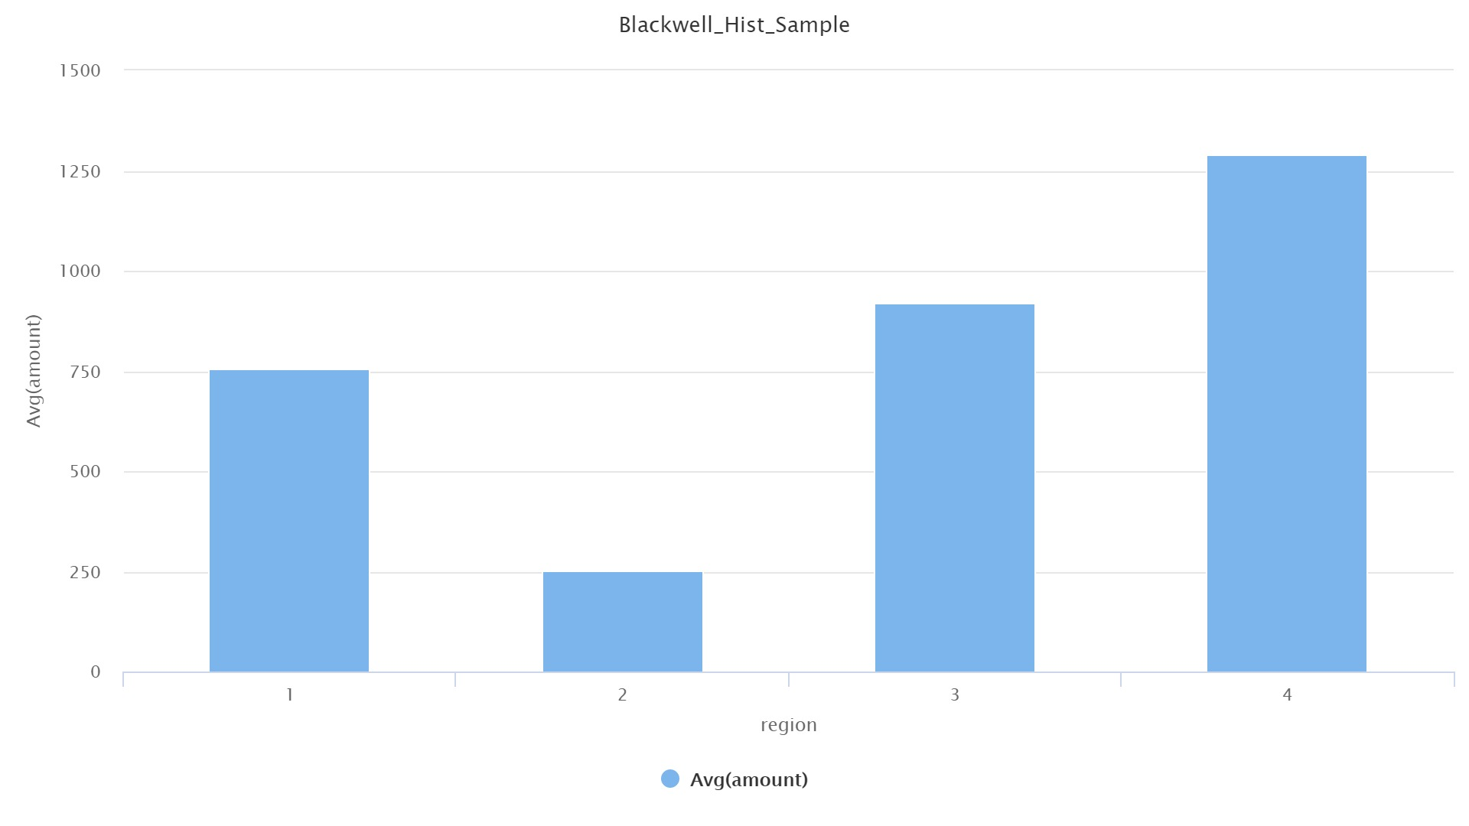

2. Which regions spend the most/least?

The chart below shows region 4 spends the most and region 2 spends the least.

3. Are there differences in the age of customers between regions?

The chart below shows the average age per region. As you can see, the average age does vary by region. The average age of the population in region 2 is the highest (oldest), and region 4 is the lowest (youngest).

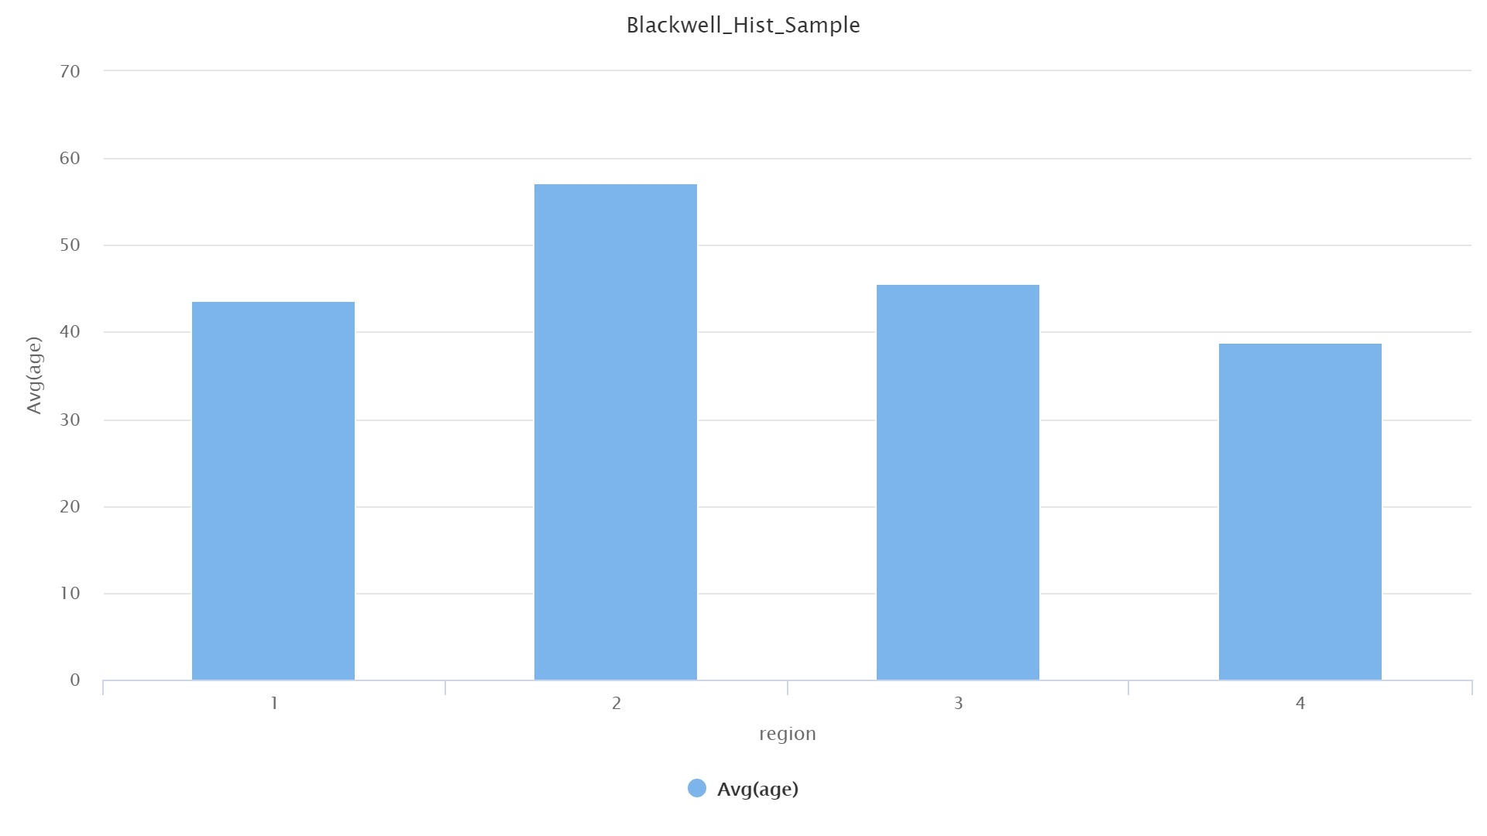

4. If so, can we predict the age of a customer in a region based on other demographic data?

Utilizing the data provided, we can only predict the age of a customer in a region accurately 36% of the time.

5. Finally, is there a relationship between number of items and amount spent?

I reviewed a correlation matrix which demonstrates the relationship between all attributes provided in the data set and the strength of a relationship between any two attributes. On the whole, it appears there is no real correlation between number of items and amount spent (-0.002). This number, which is basically zero, suggests as the number of items increases the amount increases evenly. In our data set there is not a strong correlation (positive or negative) of item count influencing amount spent. This suggests in many cases customers spend versus number of items at the spend level varies and are independent of one another.

The hypotheses presented are:

Hypothesis 1:

Older clients shop instore more than online (or younger customers tend to shop online and older clients tend to shop instore.

Based on the chart below, we could infer that younger people up to the age of about 30 actually tend to buy more instore versus online. From ages 30 – 55, on average it appears there is no strong preference for one or the other. Interestingly, there appears to be a strong preference for online purchasing between the ages of 55 – 65. The tail of ages appears to be non-preferential from 65 on up in age.

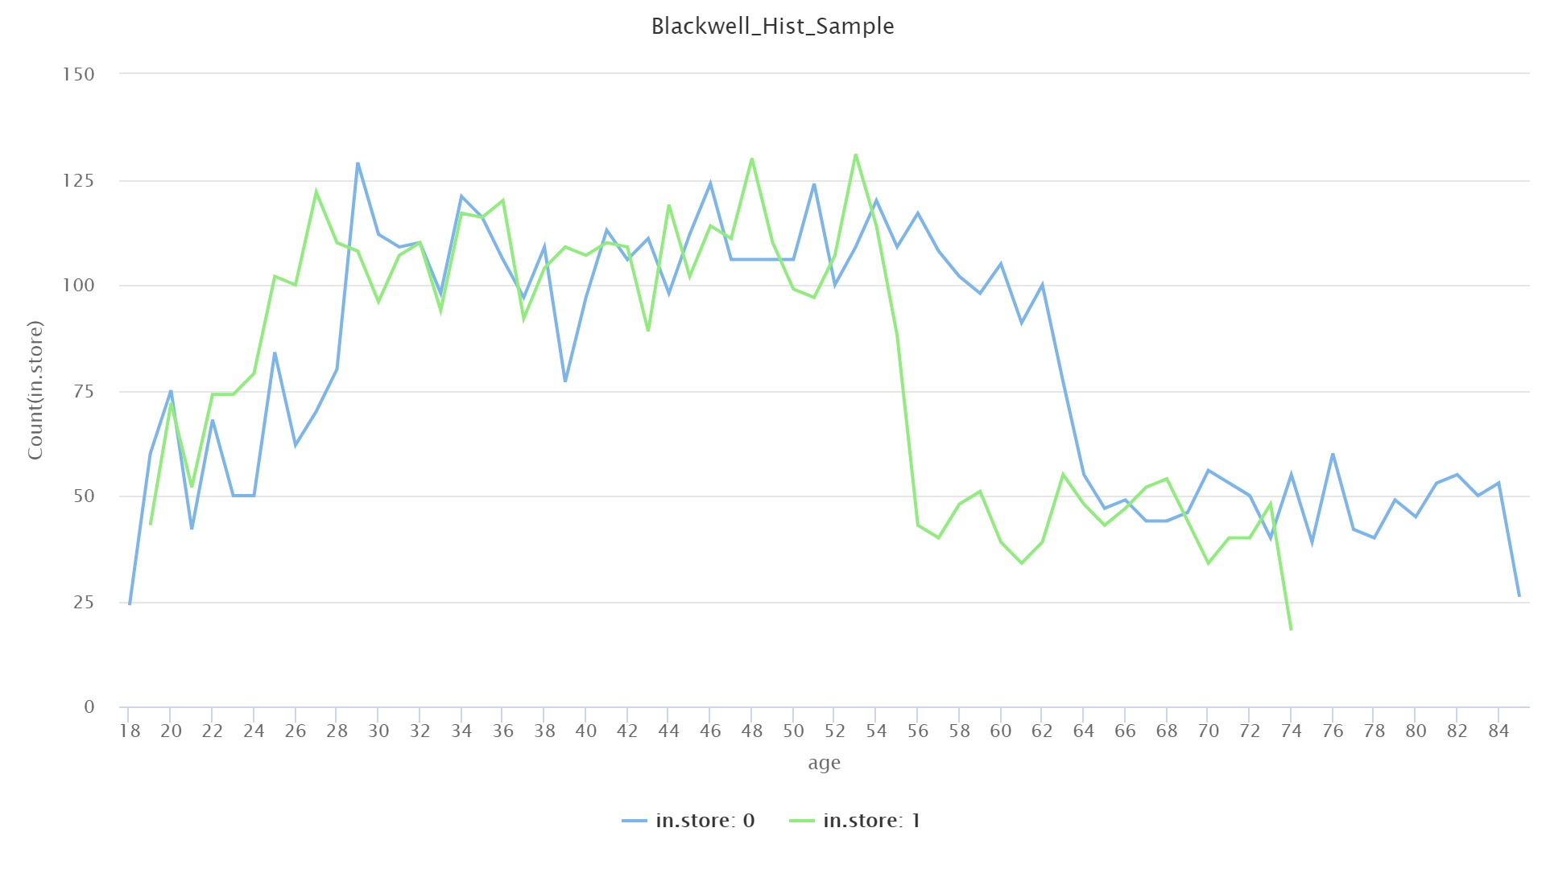

Aside from a review of the data provided, I also applied a mathematical algorithm (decision tree) to calculate most likely correlations between different attributes and a customer’s propensity to purchase instore or online.

I observed the following:

For regions 1 and 2, the region alone is the single best predictor of online or instore purchase behavior. For region 1, based on this data set, we can predict almost 80% of customers will purchase instore. For region 2, we can predict almost 100% of the time customers will purchase online.

For regions 3 and 4, the combination of the region first and then amount is the best indicator of purchase behavior.

For region 3 if the amount is less than $750 customers are most likely to purchase instore. However, for large purchases over $1500, customers are likely to purchase online. In between, $750 and $1500, my model bucketed finally on age and then number of items. However, 1650 outcomes of almost 2100 could be determined with region and amount. The need for age was only required for a subset of 500 additional outcomes. So on the whole, for region three, we can, with good confidence predict about 75% of the outcomes with region and amount. This suggests age is not really a strong indicator or purchase behavior for region 3.

Region 4 is a little more complicated. Amount contributes largely to determining the customer’s purchase behavior with all expensive ($2250 or more) purchases occurring online. Whereas for amounts under $750, and between $750 and $1500, and then again between $1500 and $2250, there is a fairly even distribution of online versus instore purchase behavior. While the model does consider age as the next indicator past region and then amount for predicting online or instore behavior, none of the outcomes are really strong indicators for age being highly impactful in predicting the outcome. For instance, consider the following branch of the model:

Region 4:
Amount ($750 - $1500):
Age ( under 34 years old): 256t, 148f – 63% are instore purchases
Age (34 to 51 years old): 297t, 161f – 64% are instore purchases
Age (51 to 68 years old): 73t, 114f – 39% are instore purchases

For region 4 there are 3200 transactions. 1000 transactions occur at this range. By the time you get down to age, while percentage in the age group looks interesting, the number of transactions represented for instance in the 51 to 68 age group is 2% of the total. It is true though that in Region 4, age is a factor for purchasing behavior, where as in Regions 1 and 2 its a nonevent, and region 3 is very much less impactful. However, on the whole, region and amount spent still drive the most influence in the model for predicting whether a customer will purchase online or instore.

Additionally, the model I created is accurate in predicting online or instore purchase behavior a little better than 81% of the time. This is likely skewed by the fact that the data set provided for Region 1 and Region 2 are so definitively conclusive – Region 2 is 100% online. It would be interesting to look at a larger sample or different random sample of regions 1 and 2 data to see if what we pulled for this assessment truly represents those regions’ customer behavior.

Based on the model results, it does appear that there is NOT a strong correlation or predictability of instore versus online purchase behavior based on age. Region and then amount are stronger indicators of customer behavior here.

Hypothesis 2:

Older customers tend to spend more money than younger customers.

The chart below shows that younger clients in the age range of 18-30 tend to spend more on average per transaction than any other group. From about 30 – 60 in age, the trend is fairly flat. There is a significant drop off in per transaction spend from age 60 and older.
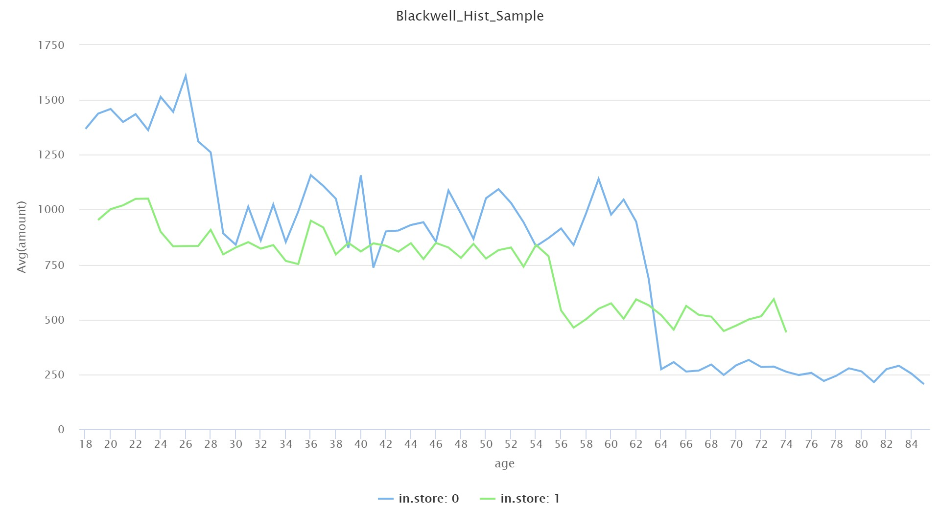

The final hypothesis is yours.

Hypothesis 3:

Spending habits are regional.

The chart below shows total spend by age by region. It is interesting to note that in all three regions total spend decreases after about 55 years of age. Otherwise, total spend by age by region is relatively flat. The data as depicted here, once again reinforces the early notion in this assessment that spend is regional.

One model I created suggests 80% accuracy in predicting instore or online purchase behavior by REGION. Again, region seems to be the strongest indicator of performance in our data set.

Based on the data provided, spending habits are regional in nature.
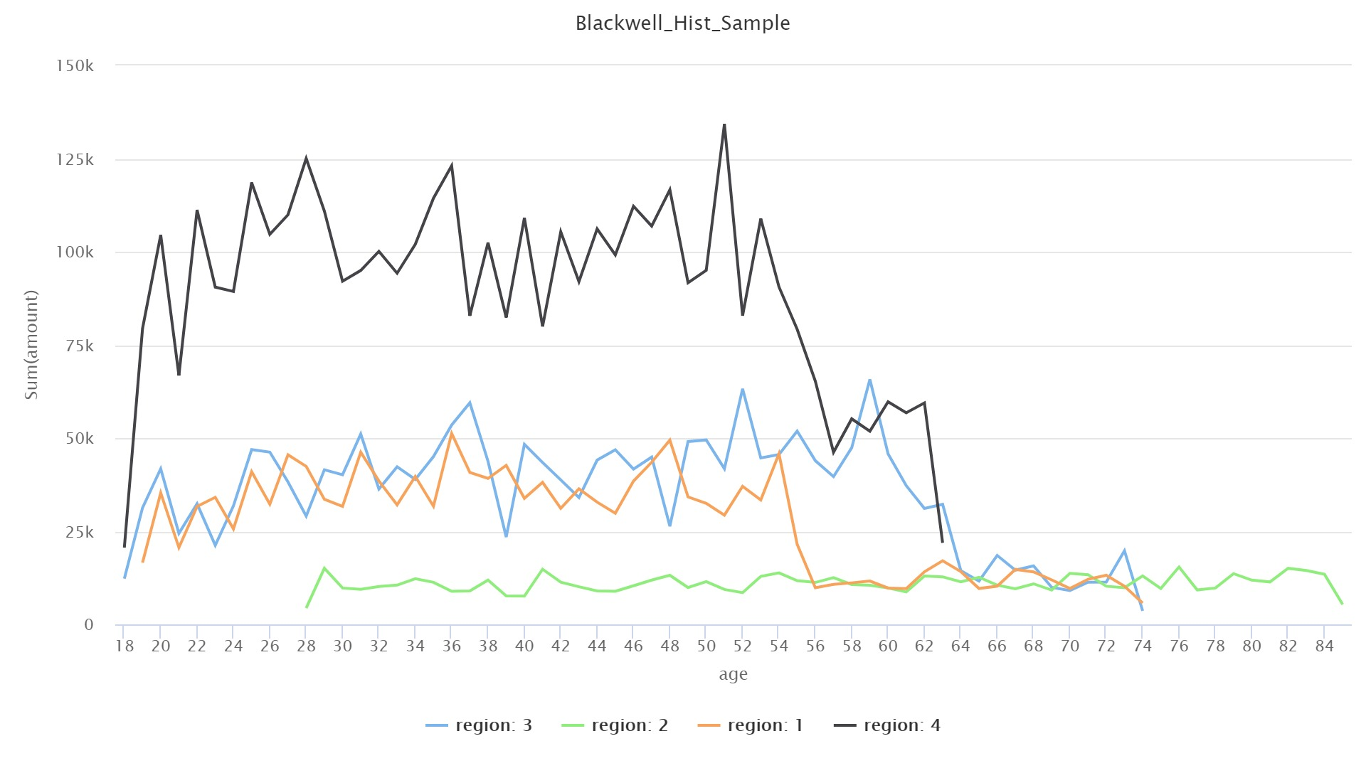
With more data, it would be interesting to see if we could figure out why one region spends more than another. Given the data we have, we can only derive the insight in this note, not regional spend causation. I would recommend digging deeper into what is driving spend in region 4 and trying to predict whether or not those factors can be replicated with some positive predictive success in the other regions in order to grow total sales. The opposite would be interesting too – what factors are driving region 2’s performance to be significantly lower than the others.

Let me know if you have any questions.

Kevin

